HackerRank Program 2
Link :- https://www.hackerrank.com/challenges/conditional-statements-in-c/problem

Successful Submission
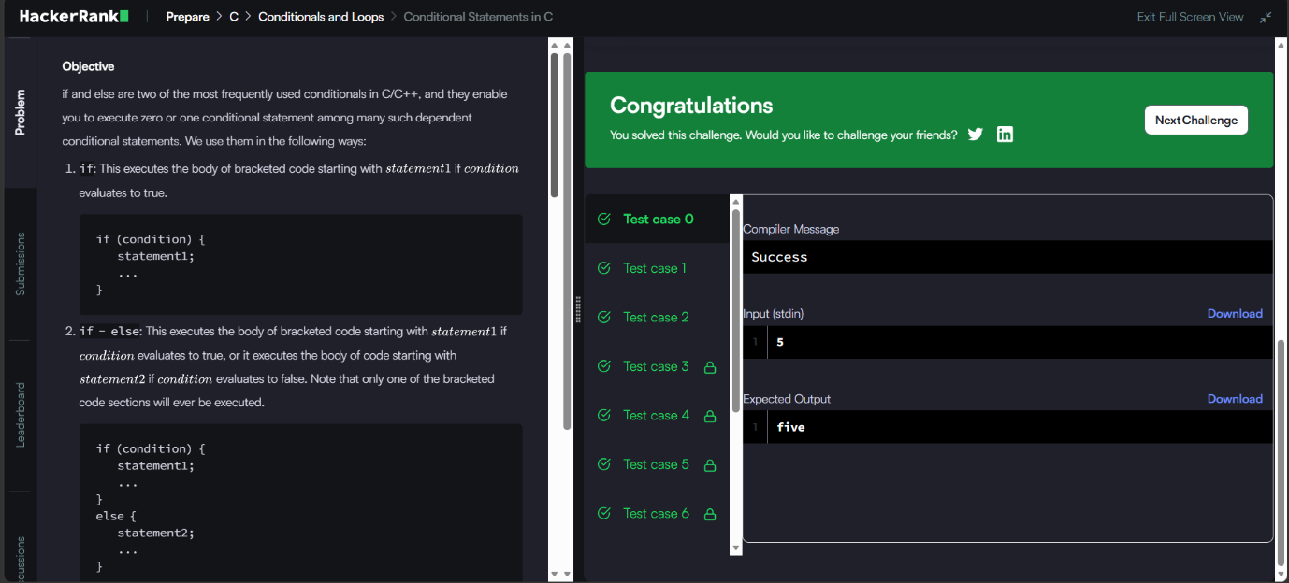
Source Code


